**Date Submitted: 10/2**

**Task 00: Execute provided code**

**Youtube Link:** [**https://youtu.be/CopjJSKdo8U**](https://youtu.be/CopjJSKdo8U)

**#include** <stdint.h>

**#include** <stdbool.h>

**#include** "inc/hw_memmap.h"

**#include** "inc/hw_types.h"

**#include** "driverlib/debug.h"

**#include** "driverlib/sysctl.h"

**#include** "driverlib/adc.h"

**#define** TARGET_IS_BLIZZARD_RB1

**#include** "driverlib/rom.h"

**#ifdef** DEBUG

void__error__(**char** *pcFilename, uint32_t ui32Line)

{

}

**#endif**

**void** **main**(**void**)

{

uint32_t ui32ADC0Value[4];

**volatile** uint32_t ui32TempAvg;

**volatile** uint32_t ui32TempValueC;

**volatile** uint32_t ui32TempValueF;

// f = 40 MHz

ROM_SysCtlClockSet(SYSCTL_SYSDIV_5|SYSCTL_USE_PLL|SYSCTL_OSC_MAIN|SYSCTL_XTAL_16MHZ);

// Enables the ADC

ROM_SysCtlPeripheralEnable(SYSCTL_PERIPH_ADC0);

ROM_ADCHardwareOversampleConfigure(ADC0_BASE, 64);

// ADC0, sample sequencer 1, processor triggers, highest priority

ROM_ADCSequenceConfigure(ADC0_BASE, 1, ADC_TRIGGER_PROCESSOR, 0);

ROM_ADCSequenceStepConfigure(ADC0_BASE, 1, 0, ADC_CTL_TS);

ROM_ADCSequenceStepConfigure(ADC0_BASE, 1, 1, ADC_CTL_TS);

ROM_ADCSequenceStepConfigure(ADC0_BASE, 1, 2, ADC_CTL_TS);

ROM_ADCSequenceStepConfigure(ADC0_BASE,1,3,ADC_CTL_TS|ADC_CTL_IE|ADC_CTL_END);

ROM_ADCSequenceEnable(ADC0_BASE, 1);

**while**(1)

{

ROM_ADCIntClear(ADC0_BASE, 1); // Clear ADC interrupt flag

ROM_ADCProcessorTrigger(ADC0_BASE, 1); // Trigger the ADC conversion

**while**(!ROM_ADCIntStatus(ADC0_BASE, 1, **false**)); // Poll until conversion completes

ROM_ADCSequenceDataGet(ADC0_BASE, 1, ui32ADC0Value); // Store the temperature value

ui32TempAvg = (ui32ADC0Value[0] + ui32ADC0Value[1] // Average the sampled temperatures

+ ui32ADC0Value[2] + ui32ADC0Value[3]

+ 2) / 4;

// Convert to Celsius

ui32TempValueC = (1475 - ((2475 * ui32TempAvg)) / 4096)/10;

// Convert to Fahrenheit

ui32TempValueF = ((ui32TempValueC * 9) + 160) / 5;

}

}

**------------------------------------------------------------------------------------**

**Task 01:**

Youtube Link: [**https://youtu.be/Nh9oje9tkrI**](https://youtu.be/Nh9oje9tkrI)

**Modified Code:**

**First modification is to change all the SS1 to SS2 for the ADC. Next, interface the LED using PF2. This LED will turn on when the temperature is above 72 Fahrenheit.**

**#include** <stdint.h>

**#include** <stdbool.h>

**#include** "inc/hw_memmap.h"

**#include** "inc/hw_types.h"

**#include** "driverlib/debug.h"

**#include** "driverlib/sysctl.h"

**#include** "driverlib/adc.h"

**#include** "driverlib/gpio.h"

**#define** TARGET_IS_BLIZZARD_RB1

**#include** "driverlib/rom.h"

**#ifdef** DEBUG

void__error__(**char** *pcFilename, uint32_t ui32Line)

{

}

**#endif**

**void** **main**(**void**)

{

// Variables

uint32_t ui32ADC0Value[4];

**volatile** uint32_t ui32TempAvg;

**volatile** uint32_t ui32TempValueC;

**volatile** uint32_t ui32TempValueF;

// f = 40 MHz

ROM_SysCtlClockSet(SYSCTL_SYSDIV_5|SYSCTL_USE_PLL|SYSCTL_OSC_MAIN|SYSCTL_XTAL_16MHZ);

// Enables the ADC and GPIOF

ROM_SysCtlPeripheralEnable(SYSCTL_PERIPH_ADC0);

ROM_SysCtlPeripheralEnable(SYSCTL_PERIPH_GPIOF);

ROM_ADCHardwareOversampleConfigure(ADC0_BASE, 64);

// ADC0, sample sequencer 2, processor triggers, highest priority

// Typo on Assignment PDF instruction for Task 01

// Task 00 already used SS1 whereas "Task01 should being using SS2"

ROM_ADCSequenceConfigure(ADC0_BASE, 2, ADC_TRIGGER_PROCESSOR, 0);

ROM_ADCSequenceStepConfigure(ADC0_BASE, 2, 0, ADC_CTL_TS);

ROM_ADCSequenceStepConfigure(ADC0_BASE, 2, 1, ADC_CTL_TS);

ROM_ADCSequenceStepConfigure(ADC0_BASE, 2, 2, ADC_CTL_TS);

ROM_ADCSequenceStepConfigure(ADC0_BASE, 2, 3, ADC_CTL_TS|ADC_CTL_IE|ADC_CTL_END);

ROM_ADCSequenceEnable(ADC0_BASE, 2);

ROM_GPIOPinTypeGPIOOutput(GPIO_PORTF_BASE, GPIO_PIN_2); // Enable PF2

**while**(1)

{

ROM_ADCIntClear(ADC0_BASE, 2); // Clear ADC interrupt flag

ROM_ADCProcessorTrigger(ADC0_BASE, 2); // Trigger the ADC conversion

**while**(!ROM_ADCIntStatus(ADC0_BASE, 2, **false**)); // Poll until conversion completes

ROM_ADCSequenceDataGet(ADC0_BASE, 2, ui32ADC0Value); // Store the temperature value

ui32TempAvg = (ui32ADC0Value[0] + ui32ADC0Value[1] // Average the sampled temperatures

+ ui32ADC0Value[2] + ui32ADC0Value[3]

+ 2) / 4;

// Convert to Celsius

ui32TempValueC = (1475 - ((2475 * ui32TempAvg)) / 4096)/10;

// Convert to Fahrenheit

ui32TempValueF = ((ui32TempValueC * 9) + 160) / 5;

// Turn on PF2 LED if temp > 72 F

**if**(ui32TempValueF > 72)

ROM_GPIOPinWrite(GPIO_PORTF_BASE, GPIO_PIN_2, 4);

**else**

ROM_GPIOPinWrite(GPIO_PORTF_BASE, GPIO_PIN_2, 0);

}

}

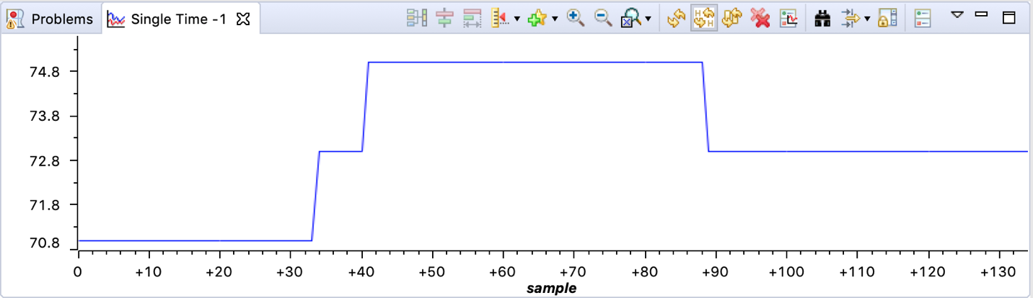

**Graphed temperature.**

**------------------------------------------------------------------------------------**

**Task 02:**

Youtube Link: [**https://youtu.be/kWaHJLC10o8**](https://youtu.be/kWaHJLC10o8)

**Modified Code:**

**First, modify the startup file to include Timer1A interrupt. Next, set up Timer1A interrupt that triggers every 0.5 s. Finally, move the ADC conversion code from the while loop and into the Timer1A ISR.**

**#include** <stdint.h>

**#include** <stdbool.h>

**#include** "inc/hw_memmap.h"

**#include** "inc/hw_types.h"

**#include** "driverlib/debug.h"

**#include** "driverlib/sysctl.h"

**#include** "driverlib/adc.h"

**#include** "driverlib/interrupt.h"

**#include** "driverlib/timer.h"

**#include** "inc/tm4c123gh6pm.h"

**#define** TARGET_IS_BLIZZARD_RB1

**#include** "driverlib/rom.h"

**#ifdef** DEBUG

void__error__(**char** *pcFilename, uint32_t ui32Line)

{

}

**#endif**

// Variables

uint32_t ui32ADC0Value[4];

uint32_t ui32Period;

**volatile** uint32_t ui32TempAvg;

**volatile** uint32_t ui32TempValueC;

**volatile** uint32_t ui32TempValueF;

**void** **main**(**void**)

{

// f = 40 MHz

ROM_SysCtlClockSet(SYSCTL_SYSDIV_5|SYSCTL_USE_PLL|SYSCTL_OSC_MAIN|SYSCTL_XTAL_16MHZ);

// Enables the ADC

ROM_SysCtlPeripheralEnable(SYSCTL_PERIPH_ADC0);

ROM_ADCHardwareOversampleConfigure(ADC0_BASE, 32); // Average at 32 samples

// ADC0, sample sequencer 1, processor triggers, highest priority

ROM_ADCSequenceConfigure(ADC0_BASE, 1, ADC_TRIGGER_PROCESSOR, 0);

ROM_ADCSequenceStepConfigure(ADC0_BASE, 1, 0, ADC_CTL_TS);

ROM_ADCSequenceStepConfigure(ADC0_BASE, 1, 1, ADC_CTL_TS);

ROM_ADCSequenceStepConfigure(ADC0_BASE, 1, 2, ADC_CTL_TS);

ROM_ADCSequenceStepConfigure(ADC0_BASE, 1, 3, ADC_CTL_TS|ADC_CTL_IE|ADC_CTL_END);

ROM_ADCSequenceEnable(ADC0_BASE, 1);

// Set up TIMER1

ROM_SysCtlPeripheralEnable(SYSCTL_PERIPH_TIMER1);

ROM_TimerConfigure(TIMER1_BASE, TIMER_CFG_PERIODIC);

// (40 MHz / 0.5 Hz)

ui32Period = ROM_SysCtlClockGet() * 0.5;

ROM_TimerLoadSet(TIMER1_BASE, TIMER_A, ui32Period - 1);

// Enable Timer1A interrupt

ROM_IntEnable(INT_TIMER1A);

ROM_TimerIntEnable(TIMER1_BASE, TIMER_TIMA_TIMEOUT);

ROM_IntMasterEnable();

// Start TIMER1A

ROM_TimerEnable(TIMER1_BASE, TIMER_A);

**while**(1)

{

}

}

// Timer 1A ISR

**void** **Timer1IntHandler**(**void**)

{

// Reset the count on Timer1

ROM_TimerDisable(TIMER1_BASE, TIMER_A); // Disable Timer1

ROM_TimerLoadSet(TIMER1_BASE, TIMER_A, ui32Period); // (40 MHz / 0.5 Hz)

ROM_TimerIntClear(TIMER1_BASE, TIMER_TIMA_TIMEOUT); // Clear Timer1A flag

// Perform ADC conversion

ROM_ADCIntClear(ADC0_BASE, 1); // Clear ADC interrupt flag

ROM_ADCProcessorTrigger(ADC0_BASE, 1); // Trigger the ADC conversion

**while**(!ROM_ADCIntStatus(ADC0_BASE, 1, **false**)); // Poll until conversion completes

ROM_ADCSequenceDataGet(ADC0_BASE, 1, ui32ADC0Value); // Store the temperature value

ui32TempAvg = (ui32ADC0Value[0] + ui32ADC0Value[1] // Average the sampled temperatures

+ ui32ADC0Value[2] + ui32ADC0Value[3]

+ 2) / 4;

// Convert to Celsius

ui32TempValueC = (1475 - ((2475 * ui32TempAvg)) / 4096)/10;

// Convert to Fahrenheit

ui32TempValueF = ((ui32TempValueC * 9) + 160) / 5;

ROM_TimerEnable(TIMER1_BASE, TIMER_A); // Re-enable Timer1

}

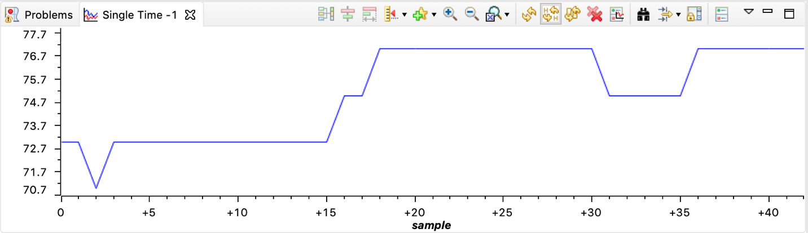

**Graphed temperature: Since the conversion is done every 0.5 s, there is less samples taken compared to Task 01.**

**------------------------------------------------------------------------------------**